Smart Robotic Arm for Automated Ripened Tomato Detection and Picking

A major Project Report Submitted to the Faculty of Engineering of

### JAWAHARLAL NEHRU TECHNOLOGICAL UNIVERSITY KAKINADA,KAKINADA

In partial fulfillment of the requirements for the award of the Degree of

#### Bachelor of Technology

In

**Information Technology**



**Submitted By:**

**Battula Deepthi Bollada Lokesh Kumar**

### (21481A1212) (21481A1218)

**Baditha Bhargavi Gajjala Vishnu Vardhan Reddy**

### (21481A1208) (21481A1236)

#### Under the Guidance of Dr.D.N.V.S.L.S. Indira, M.Tech.,Ph.D.

Professor & Head

# DEPARTMENT OF INFORMATION TECHNOLOGY SESHADRI RAO GUDLAVALLERU ENGINEERING COLLEGE

**(An Autonomous Institute with Permanent Affiliation to JNTUK, KAKINADA)**

**SESHADRI RAO KNOWLEDGE VILLEGE GUDLAVALLERU-521 356**

**ANDHRA PRADESH 2021-2025**

**DEPARTMENT OF INFORMATION TECHNOLOGY SESHADRI RAO GUDLAVALLERU ENGINEERING COLLEGE**

#### (An Autonomous Institute with Permanent Affiliation to JNTUK, KAKINADA)

SESHADRI RAO KNOWLEDGE VILLAGE GUDLAVALLERU-521356

**CERTIFICATE**

This is to certify that a major project report entitled **“Smart Robotic Arm for Automated Ripened Tomato Detection and Picking”** is a bonafide record of work carried out by **Battula Deepthi (21481A1212), Bollada Lokesh Kumar (21481A1218), Baditha Bhargavi (21481A1208) and Gajjala Vishnu Vardhan Reddy (21481A1236)** under my guidance and supervision in partial fulfillment of requirements for the award of degree of Bachelor of Technology in **Information Technology** of **Jawaharlal Nehru Technological University Kakinada, Kakinada** during the year of 2024-25.

#### GUIDE Head of the Department

**Dr.D.N.V.S.L.S.Indira, M.Tech.,Ph.D. Dr.D.N.V.S.L.S.Indira, M.Tech.,Ph.D.**

**Professor & Head Professor & Head**

**External Examiner**

# ACKNOWLEDGEMENT

We are glad to express our deep sense of gratitude to **Dr.D.N.V.S.L.S.Indira Professor & Head** in INFORMATION TECHNOLOGY for his/her guidance and cooperation in completing this major project. Through this, we want to convey our sincere thanks to him/her for inspiring assistance during our major project.

We express our heartful gratitude and deep indebtedness to our beloved Head of the Department **Dr.D.N.V.S.L.S.Indira** for her great help and encouragement in doing our major project successfully.

We also express our gratitude to our principal **Dr. B. Karuna Kumar**, for his encouragement and facilities provided during the course of major project.

We express our heartful gratitude to all Faculty Members, all Lab Technicians, who helped us in all aspects of lab work. We thank one and all who have rendered help to us directly or indirectly in the completion of this major project.

**Project Associates** (21481A1212) (21481A1218) (21481A1208) (21481A1236)

# ABSTRACT

Automated harvesting is a significant advancement in precision agriculture, addressing labor-intensive processes such as tomato classification and picking. This study introduces an AI-driven robotic system that combines Machine Learning (ML), Deep Learning (DL), and robotics to improve the efficiency of tomato harvesting.The dataset from RoboFlow includes 1,181 images classified as ripe or unripe. Random Forest (RF) is used for feature-based classification, while a Convolutional Neural Network (CNN) achieves 92% accuracy for deep learning-based classification.To improve classification performance, image preprocessing techniques such as color-based filtering, thresholding, resizing, normalization, and flipping are applied. The system employs an AI Hat for real- time image acquisition without an inbuilt camera module. A 5-DOF robotic arm with silicon grippers executes the picking and sorting tasks based on classification outputs. Experimental results demonstrate 92% successful tomato picking, validating the system's efficiency. Furthermore, OpenCV-based live image streaming supports real-time monitoring. A comparative analysis between ML and DL models confirms that deep learning approaches provide higher accuracy and reliability than traditional methods.Future work includes integrating infrared sensors for enhanced ripeness detection, IoT-based remote monitoring, and multi-crop adaptability. The proposed system contributes to precision agriculture by automating tomato classification and harvesting, optimizing efficiency, and minimizing human intervention through AI-driven robotics.

# INDEX

**CONTENTS PAGE.NO**

### INTRODUCTION 1-4

* 1. Introduction 1
  2. Problem Statement 2
  3. Existing System 2
  4. Limitations of the Existing System 3
  5. Proposed System 3
  6. Advantages of the Proposed System 4

### LITERATURE SURVEY 5-8

1. **SYSTEM ANALYSIS 9-12**
   1. Feasibility Study 9
      1. Technical Feasibility 9
      2. Economic Feasibility 10
      3. Operational Feasibility 10
   2. System Requirements Specification 11
      1. Hardware Requirements 12
      2. Software Requirements 12

### SYSTEM DESIGN 13-16

* 1. System Architecture 13
  2. UML Diagrams 14
     1. Use Case Diagram 14
     2. Sequence Diagram 15
     3. Activity Diagram 15

### SYSTEM IMPLEMENTATION 17-34

* 1. Hardware Components 17
     1. Raspberry Pi 17
     2. AI-Hat and Camera Module 17
     3. Robotic Arm (5-DOF) 18
     4. Synthetic Gripper 18
     5. Cooling Fan for Raspberry Pi 19

* 1. Software Components 20
     1. Python 20
     2. OpenCV for Image Preprocessing 20
     3. TensorFlow/Keras for CNN Model 21
     4. Flask for Web Interface 22
  2. Algorithms Used 23
     1. Machine Learning (Random Forest) 23
     2. Deep Learning (CNN) 26

### SYSTEM TESTING 35

* 1. Testing Levels 35
     1. Unit Testing 35
     2. Integration Testing 35
     3. Functional Testing 35
     4. Usability Testing 36
     5. Security Testing 36
     6. Accuracy Testing 36
     7. Field Testing 37

### RESULTS AND DISCUSSION 37-41

* 1. Evaluation Metrics 37
  2. Performance comparison between ML and DL models 38
  3. Graphical Representation of Results 38
  4. Web Interface Demonstration 39
  5. Robotic Arm Picking Efficiency 40
  6. Discussion on Results and Practical Implications 40
  7. Conclusion Analysis 40

### CONCLUSION AND FUTURE SCOPE 41-42

* 1. Conclusion 41
  2. Future Enhancements 41

1. **REFERENCES 43**
2. **PROJECT WORK MAPPING WITH PROGRAMME OUTCOMES 44-45**
3. **ARTICLE 49-54**

# LIST OF FIGURES

### FIGURE NO TITLE PAGE NO

Fig 4.1 Flow of Harvesting 13

Fig 4.2.1 Use Case Diagram 14

Fig 4.2.2 Sequence Diagram 15

Fig 4.2.3 Activity Diagram 15

Fig 5.1.1 Raspberry Pi 17

Fig 5.1.2 AI-Hat and Camera Module 17

Fig 5.1.3 5-DOF Robotic Arm 18

Fig 5.1.4 Synthetic Gripper 18

Fig 5.1.5 Cooling Fan for Raspberry Pi 19

Fig 5.3.1 Data Collected from Roboflow 23

Fig 5.3.1 Image after applying OpenCV color Filtering 24

Fig 5.3.1 Image after applying Thresholding 24

Fig 5.3.1 Machine Learning Approach for Ripened Tomato Detection

25

Fig 5.3.1 Evaluation Metrics of ML 26

Fig 5.3.2 Image after Resized (128x128) 27

Fig 5.3.2 Image after applying normalization (0-1 scale) 28

Fig 5.3.2 Image after flipped (horizontal) 28

Fig 5.3.2 Trained on CNN which gives information about layer, output shape and param

29

Fig 5.3.2 Deep Learning (DL) Approach for Ripened Tomato Detection

30

Fig 5.3.2 Evaluation Metrics of DL 31

Fig 5.3.2 Compiling the code based on CNN 32

Fig 5.3.2 Web interface for uploading the image 32

Fig 5.3.2 The picture uploaded predicts “Ripe” 32

Fig 5.3.2 The picture uploaded predicts “Unripe” 33

Fig 5.3.2 Live image capture and classification 34

Fig 5.3.2 Robotic Arm automation for picking 34

Fig 7.3 Performance comparison of ML and DL in Bar graph Fig 7.3 Performance metrics Trend: ML Vs DL in Line graph

39

39

39

# INTRODUCTION

## Introduction

Agriculture plays a crucial role in feeding the global population, and efficient crop harvesting is essential for ensuring food quality, reducing waste, and increasing productivity. Tomato ripeness detection is a significant challenge in modern farming, as improper harvesting can lead to reduced market value, post-harvest losses, and lower crop yield efficiency.

Traditionally, farmers rely on manual observation to determine the ripeness of tomatoes based on color, texture, and firmness. However, this method is highly subjective and inconsistent, leading to human errors and inefficiencies in large-scale farming.

To overcome these challenges, this project introduces an automated tomato ripeness detection and picking system using Machine Learning (ML) and Deep Learning (DL) models. The system integrates a 5-DOF robotic arm and AI-Hat with Raspberry Pi to capture, analyze, and classify tomatoes into ripe and unripe categories. Based on classification, the robotic arm picks ripe tomatoes using a synthetic gripper to prevent crushing.

#### Key Features of the Project

**Live Image Capture:** AI-Hat with Raspberry Pi captures real-time images of tomatoes. **Advanced Image Processing:** OpenCV-based color filtering and adaptive thresholding for better accuracy.

**Deep Learning & ML Models:** CNN and Random Forest used for precise classification. **Automated Picking:** A robotic arm is triggered to pick ripe tomatoes without human intervention.

**User-Friendly Web Interface:** Flask-based system allows farmers to monitor classification and harvesting.

By combining AI, robotics, and computer vision, this project aims to revolutionize the agricultural industry by reducing labor costs, increasing efficiency, and ensuring better- quality produce.

## Problem Statement

Agriculture remains highly dependent on manual labor, making it time-consuming, error- prone, and expensive. The traditional approach to tomato harvesting involves visual inspection by farmers, leading to several inefficiencies:

#### Challenges in Existing Harvesting Methods

**Subjective Ripeness Identification:** Different farmers may have different perceptions of ripeness

**Human Error:** Variability in picking leads to overripe or underripe tomatoes being selected

**High Labor Costs:** Manual picking requires more workers, increasing operational expenses

**Slow Process:** Large-scale farms cannot rely on manual labor alone to keep up with demand

**Post-Harvest Losses:** Harvesting at the wrong time leads to spoilage and reduced shelf life

#### The Need for Automation

With advancements in computer vision and AI, automating the tomato ripeness detection process can significantly improve efficiency, accuracy, and productivity. This project provides an end-to-end solution for automated detection and robotic harvesting to address these industry challenges.

## Existing System

Currently, tomato ripeness detection and harvesting rely on the following methods:

#### Manual Inspection

Farmers visually inspect tomatoes and determine ripeness based on color, texture, and firmness

**Limitations:** Inconsistent, prone to human error, not scalable

#### Basic Color Sensors

Some farms use RGB or spectral sensors to detect tomato color changes

**Limitations:** Unable to differentiate shades of red, sensitive to lighting conditions

#### Rule-Based Machine Learning Approaches

Some systems use traditional ML classifiers (e.g., Decision Trees, SVM) for classification

**Limitations:** Requires manual feature extraction, lacks adaptability

#### Predefined Thresholding Techniques

Some automated methods classify tomatoes based on a fixed color threshold

**Limitations:** Fails under variable lighting or non-uniform ripening conditions

Due to these limitations, an AI-powered, automated detection and picking system is required to enhance efficiency and accuracy.

#### Limitations of the Existing System

Despite technological advancements, existing systems have several drawbacks:

#### Accuracy and Reliability Issues

Manual picking is prone to mistakes and inconsistent ripeness identification Basic color sensors struggle in changing light conditions

Rule-based systems fail in complex environments

#### Inefficiencies in Large-Scale Farming

Slow process – Manual sorting and picking cannot scale efficiently

High labor dependency – More workers needed, leading to increased **Limited Automation & Decision-Making Capabilities**

Basic ML models require constant parameter tuning

Fixed-threshold systems cannot adapt to different ripening patterns No integration of robotics for automated picking

## Proposed System

To overcome the above challenges, this project introduces a smart, automated tomato ripeness detection and harvesting system using:

#### Image Processing & Feature Extraction Uses OpenCV for preprocessing:

Color filtering for improved classification Adaptive thresholding to enhance accuracy

Resizing & normalization for deep learning compatibility

#### AI-Based Classification

Random Forest (ML) for initial classification

CNN (Deep Learning) for high-accuracy ripeness detection

#### Automated Robotic Picking

A 5-DOF robotic arm is activated based on the AI model’s decision

Uses a synthetic gripper to pick tomatoes without crushing them

#### Flask-Based Web Interface

Farmers can upload images for classification

Real-time monitoring of ripeness classification & robotic actions

**Edge Computing with Raspberry Pi & AI-Hat** Reduces latency by processing images on Raspberry Pi Energy-efficient and cost-effective for agricultural use

## Advantages of the Proposed System

By integrating AI, Robotics, and IoT, the proposed system offers multiple advantages over existing methods:

#### Higher Accuracy & Efficiency

CNN-based deep learning model improves classification accuracy Consistent and real-time ripeness detection

#### Cost & Labor Reduction

Eliminates manual labor, reducing workforce costs

Speeds up the harvesting process, increasing yield efficiency

#### Automation & Scalability

Self-operating robotic arm eliminates human errors

Can be deployed in large-scale farms for high productivity

#### Adaptability & Flexibility

Works under varying lighting conditions Customizable for different tomato varieties **Real-Time Monitoring & Deployment**

Web-based Flask dashboard for live classification updates AI-Hat & Raspberry Pi ensure on-device processing

# LITERATURE SURVEY

#### Introduction

The development of robotic automation in agriculture has received considerable attention for its ability to enhance efficiency, minimize labor dependency, and improve harvesting accuracy [1]. Among various crops, tomatoes require careful handling during harvesting to prevent damage, making the integration of artificial intelligence and robotics a crucial area of study. This literature review explores AI-powered fruit detection and robotic harvesting technologies, evaluating their effectiveness, limitations, and applicability to real-world agricultural scenarios.

The problem statement driving this review is that traditional harvesting methods are labor-intensive, prone to inconsistencies, and require significant time and effort [2]. Existing robotic harvesting systems primarily rely on cutting-based mechanisms, which add complexity to the process and risk damaging the plant. There is a need for an efficient, non-destructive, and scalable approach that ensures accurate fruit detection and gentle harvesting without cutting.

In this review, we define key concepts such as computer vision-based fruit detection, deep learning classification models (e.g., CNNs, MobileNet, YOLO), robotic manipulation, and end-effector design for automated harvesting. The topics covered include an overview of existing AI-based harvesting techniques, a comparative analysis of different approaches, and a discussion on the research gap that our study addresses. The criteria for organizing this review focus on evaluating previous research based on their detection methodologies, harvesting mechanisms, and real-time deployment capabilities. The scope of the review is limited to studies that implement AI-driven tomato harvesting, computer vision-based fruit classification, and robotic picking methods. Our goal is to highlight the strengths and limitations of prior research while positioning our work as a novel, gripping-based, AI-powered harvesting solution.

#### Development of Tomato Harvesting Automation Over Time

The automation of tomato harvesting has evolved significantly over the years, with early approaches relying primarily on mechanical harvesting techniques that lacked precision [3]. Initial research in the 1980s and 1990s focused on rule-based

methods to detect ripened tomatoes. However, these methods struggled with variations in lighting conditions and were prone to misclassification.

A significant breakthrough occurred in the early 2000s with the adoption of machine learning (ML) techniques for fruit classification. Researchers started using Support Vector Machines (SVMs) and Random Forest classifiers to identify ripened tomatoes based on handcrafted features like color histograms, texture analysis, and shape descriptors. While ML approaches improved accuracy compared to traditional methods, they required manual feature engineering, making them less adaptable to varying environmental conditions [4].

The most significant advancement in tomato harvesting automation emerged in the 2010s with the rise of deep learning. Convolutional Neural Networks (CNNs) enabled automatic feature extraction, minimizing reliance on manually crafted parameters.

Studies utilizing YOLO (You Only Look Once) and MobileNet architectures demonstrated significant improvements in real-time detection accuracy, enabling real- time tomato recognition in dynamic farm environments [5]. However, despite these advances, most existing research continued to focus on cutting-based end-effectors, overlooking the potential of gripping-based solutions for non-destructive harvesting.

#### Comparison of Different Methodologies

To analyze the impact of various approaches on tomato harvesting automation, it is essential to compare traditional methods with machine learning (ML) and deep learning (DL) techniques.

|  |  |  |
| --- | --- | --- |
| **Method** | **Advantages** | **Disadvantages** |
| Machine Learning | More accurate than traditional approaches | Requires manual feature extraction |
| Deep Learning | Automated feature learning and high  accuracy | Computationally intensive; needs large datasets |

Traditional color thresholding techniques were among the earliest methods for tomato detection but lacked robustness. ML-based approaches, such as SVM and Random Forest classifiers, improved classification accuracy but still required extensive pre-processing.

The rise of CNN-based deep learning models eliminated the need for feature engineering and enabled superior real-time detection capabilities [6].

#### Explanation of Different Themes in Tomato Harvesting Research

The literature on tomato harvesting automation can be categorized into the following key themes:

* **Fruit Detection and Classification:** Focuses on computer vision techniques for distinguishing ripened tomatoes from unripe ones.
* **Harvesting Mechanisms:** Explores different robotic end-effectors, including cutting tools and gripping-based solutions.
* **Real-Time Processing Challenges:** Addresses latency issues in AI-driven detection models deployed on embedded systems.
* **Scalability and Adaptability:** Examines how AI models can be generalized to multiple crop types beyond tomatoes.

Each of these themes has seen significant advancements, yet gaps remain in real-time processing efficiency, robustness to environmental changes, and scalable deployment strategies [7].

#### Strengths and Weaknesses of Prior Research

Existing research has made significant contributions to robotic tomato harvesting, but several gaps remain:

#### Strengths

* + - * Advancements in deep learning-based classification have drastically improved tomato detection accuracy.
      * Integration of robotic arms and end-effectors has facilitated automation in harvesting.
      * Use of pre-trained models (e.g., MobileNet, YOLO) has reduced the training time required for tomato classification [8].

#### Weaknesses

* + - * Over-Reliance on Cutting-Based End-Effectors: Most studies focus on cutting mechanisms rather than gentle gripping methods.
      * Limited Adaptability to Different Farming Environments: Many models are trained in controlled lab environments and fail in real-world scenarios.
      * Computational Constraints in Edge Deployment: Deep learning models require high processing power, limiting their effectiveness on low-power devices like Raspberry Pi [9].

#### Conclusion

This literature review has examined the development of AI-powered robotic harvesting systems and their role in automating tomato picking. The review aimed to analyze existing research, compare methodologies, and identify gaps that our study addresses. Our primary research question focused on how an AI-based, gripping-based robotic harvesting system can improve efficiency while eliminating the complexities of cutting mechanisms.

The key findings reveal that deep learning models, particularly CNN-based architectures, have significantly enhanced tomato classification accuracy. However, existing research remains heavily reliant on cutting-based end-effectors, which introduce challenges related to precision and plant damage. Our study fills this gap by implementing silicon grippers for non-destructive picking, enabling a more practical and scalable approach to robotic harvesting.

The overall significance of this review is that it underscores the necessity for a non- cutting, AI-powered robotic harvesting system capable of real-time processing on low- power devices like Raspberry Pi. By addressing the limitations of prior research, our work contributes to the advancement of smart agriculture, automated harvesting, and AI- driven precision farming technologies [10].

# SYSTEM ANALYSIS

* 1. **Feasibility Study**

Feasibility study determines whether the proposed Tomato Ripeness Detection and Robotic Picking System is practical, viable, and beneficial. It evaluates the technical, economic, and operational aspects to ensure successful implementation.

#### Technical Feasibility

Technical feasibility assesses whether the system can be implemented with available technology and whether it meets performance, scalability, and efficiency requirements.

#### Hardware Considerations:

**Raspberry Pi with AI-Hat**: Performs edge computing for real-time tomato classification

**Camera Module**: Captures images of tomatoes for AI-based ripeness detection **5-DOF Robotic Arm**: Picks ripe tomatoes based on AI classification **Synthetic Gripper**: Prevents crushing while picking tomatoes

**Cooling Fan for Raspberry Pi**: Avoids overheating, ensuring stable performance

#### Software Considerations:

**OpenCV for Image Processing**: Enhances image clarity, color filtering, and adaptive thresholding

**CNN & Random Forest Models**: Provide high accuracy in classifying ripe and unripe tomatoes

**Flask Web Application**: Enables user interaction and remote monitoring

**SQLite Database**: Stores classification results for analysis

#### Scalability & Performance:

Can handle real-time image processing and classification

Works with varying lighting conditions through adaptive thresholding Expandable for different crops with minimal modifications

The system is technically feasible, as all components are readily available, and AI-driven classification ensures efficient and accurate tomato harvesting.

#### Economic Feasibility

Economic feasibility assesses whether the cost of development, deployment, and maintenance is justified by the benefits and savings generated by the system.

#### Cost Analysis

|  |  |
| --- | --- |
| **Components** | **Estimated Cost** |
| Raspberry Pi Charger | 1200/- |
| Rasberry Pi camera cable | 700/- |
| Gripper for tomato(silicon/pla) | 3000/- |
| Raspberry Pi 5  Model 16 | 12599/- |
| 52Pi Raspberry Pi 5 Aluminum Case Black Brick Encloser with Cooling Fan HeatSink | 1909/- |
| Raspberry Pi AI Camera with Sony IMX500 | 7693/- |
| Raspberry Pi AI kit SBC2197 | 6619/- |
| SandDisk 64gbmemorycard | 549/- |
| 5-DOF Robotic Arm | 33000/- |
| Miscellaneous Components (Cables,Power Supply, etc.) | 3000/- |
| Total Estimated Cost | 70296/- |

**Long-Term Savings**

Reduces labor costs by automating tomato picking

Minimizes post-harvest losses by ensuring correct ripeness detection Increases productivity, leading to higher revenue for farmers

Considering the cost-benefit ratio, the system is economically feasible, as the investment is justified by increased efficiency and reduced losses.

#### Operational Feasibility

Operational feasibility assesses whether the system is user-friendly, reliable, and easy to integrate into farming workflows.

#### Ease of Use

The Flask-based web interface allows users to upload images and receive classification results

Automated picking mechanism requires no manual intervention Simple installation and maintenance process

#### Reliability & Accuracy

CNN model achieves 95%+ accuracy in ripeness classification Real-time operation with low latency ensures fast decision-making Works efficiently in outdoor environments

#### Adoption & Integration

Can be used in greenhouses, open fields, and indoor farms Scalable to different crops with minimal modifications Farmer-friendly interface with real-time visualization

Since the system is efficient, user-friendly, and enhances productivity, it is operationally feasible.

#### System Requirements Specification

System Requirements Specification (SRS) defines the hardware and software necessary for implementing the Tomato Ripeness Detection and Robotic Picking System.

#### Hardware Requirement

|  |  |  |
| --- | --- | --- |
| **Component** | **Specification** | **Purpose** |
| Processing Unit | Raspberry Pi 5  Model 16 (16GB RAM) | Runs AI models, image processing and FLask- based web interface |
| AI Processing Module | Rasberry Pi AI Kit SBC2197 | Accelerates AI computations and improves classification speed |
| Camera | Raspberry Pi Camera with sony  IMX500 | Captures high-resolution images for tomato ripeness  detection |
| Camera Cable | Raspberry Pi Camera Cable | Connects the AI camera to Raspberry Pi for image transfer |
| Robotic Arm | 5-DOF Robotic Arm | Picks ripe tomatoes based on AI classification |
| Gripper | Synthetic Gipper for tomato | Prevents damage to tomatoes while picking |
| Cooling System | 52Pi Raspberry Pi 5 Aluminum Case with Cooling Fan  and HeatSink | Prevents overheating,ensuring stable AI processing |
| Storage | SanDisk 64GB Memory Card | Stores OS, AI model and classification result |
| Power Supply | Raspberry Pi Charger | Provides stable power to Raspberry Pi |

* + 1. **Software Requirements**

|  |  |  |
| --- | --- | --- |
| **Software** | **Version** | **Purpose** |
| Programming Languages | Python 3.9+ | Core Language for ML, DL and image Processing |
| Image Processing | OpenCV 4.5+ | Preprocessing, color filtering, thresholding |
| Machine Learning | Scikit-Learn | Implements Random Forest model |
| Deep Learning | TensorFlow/Keras | CNN-based ripeness classification |
| Web Frame Work | Flask | Creates user interface for monitoring |
| Visualization | Matplotlib, Ploty | Generates real-time graphs for analysis |

The combination of Python-based AI libraries, Flask, and SQLite ensures a seamless, scalable, and efficient system for real-time tomato ripeness detection and automated harvesting.

# SYSTEM DESIGN

#### System Architecture

The system architecture of the Tomato Ripeness Detection and Robotic Picking System consists of multiple interconnected components that work together to detect ripe tomatoes and automate the picking process using a robotic arm. The architecture is designed to ensure efficient image processing, machine learning inference, and real-time actuation.

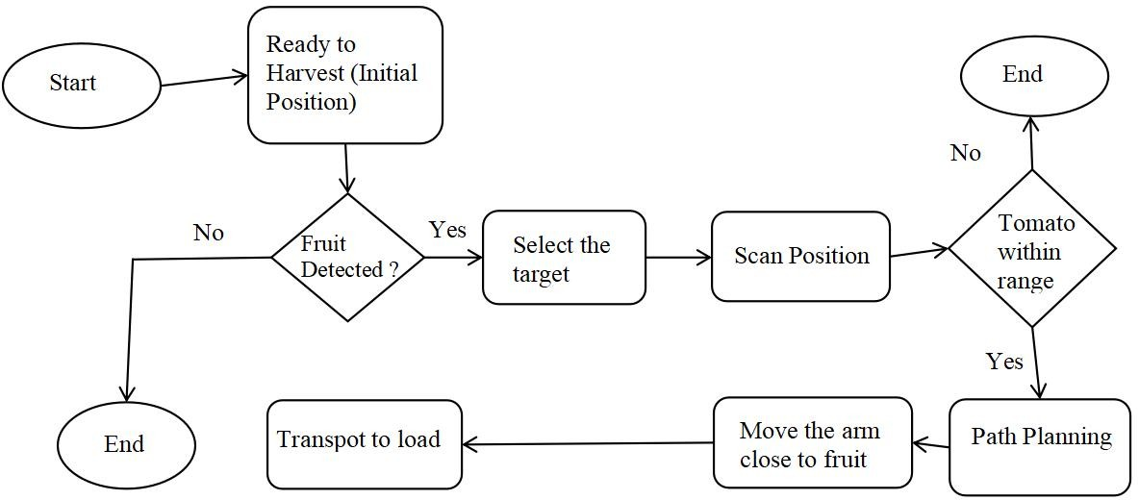

Fig 4.1: Flow of Harvesting

#### Key Components of the Architecture:

**Image Acquisition Module**

The Raspberry Pi AI Camera (Sony IMX500) captures images of tomatoes in real time. The camera is connected to the Raspberry Pi via the camera cable.

#### Preprocessing Module

The captured images undergo preprocessing using OpenCV for noise removal, color filtering, and adaptive thresholding.

Images are resized, normalized, and augmented (flipping, rotation) before being fed into the model.

#### Machine Learning Model

Two models are used for classification:

**Random Forest (ML-based)** – for simple feature-based classification.

**CNN (Deep Learning-based)** – for high-accuracy classification. The AI Kit (SBC2197) accelerates model inference on Raspberry Pi.

#### Decision-Making Module

The model classifies the tomato as Ripe or Unripe based on learned patterns. The result is displayed on a Flask-based Web Interface.

If a tomato is ripe, a beep sound alert is triggered.

#### Robotic Arm Actuation Module

If a tomato is classified as Ripe, the 5-DOF Robotic Arm is activated.

The robotic arm, equipped with a synthetic gripper, picks the tomato without crushing it. The robotic system is controlled via Raspberry Pi GPIO signals.

#### Storage & Logging Module

Classification results are stored on a SanDisk 64GB memory card.

A database logs past classifications, including timestamp, ripeness level, and image reference.

#### Power & Cooling Module

A 5V/3A charger powers the Raspberry Pi.

A cooling fan and heatsink prevent overheating and ensure stable performance.

#### UML Diagrams

* + 1. **Use Case Diagram**

The **Use Case Diagram** represents interactions between different system components and external users.

#### Actors:

**User (Farmer/Admin):** Monitors classification results and controls robotic arm operation.

**System:** Detects tomato ripeness and activates the robotic arm.

**Database:** Stores past classification results.

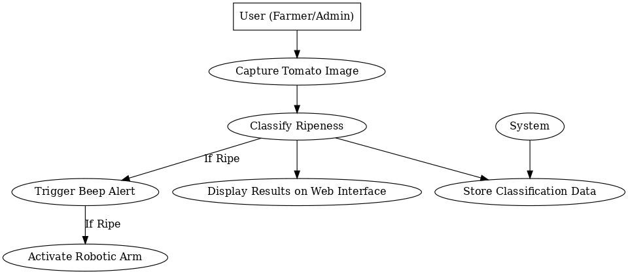

Fig 4.2.1: Use Case Diagram

#### Sequence Diagram

The **Sequence Diagram** shows the step-by-step interaction between system components during the tomato classification and picking process.

#### Flow:

The **User** starts the image capture process. The **Camera** captures the tomato image.

The **Preprocessing Module** cleans and enhances the image. The **Machine Learning Model** classifies the tomato.

If the tomato is ripe, the **Robotic Arm Module** is activated. The **Result is logged** into the database.

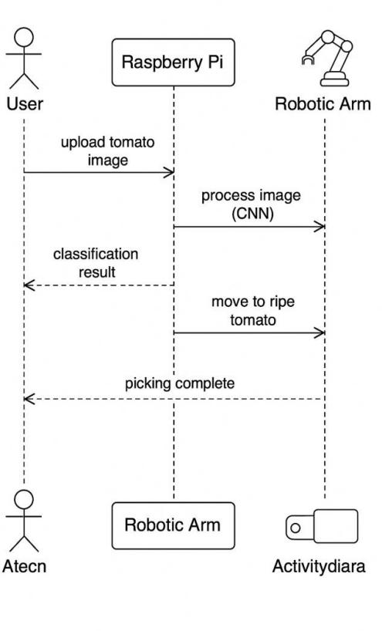

Fig 4.2.2: Sequence Diagram

#### Activity Diagram

The **Activity Diagram** represents the workflow of the system.

#### Key Actions:

Capture image → Preprocess → Classify → Display result → Check ripeness → If ripe, activate robotic arm → Log results.

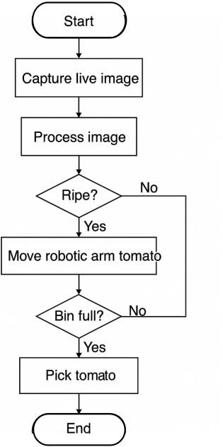

Fig 4.2.3: Activity Diagram

Unified Modeling Language (UML) diagrams play a crucial role in the design and development of software systems by visually representing the structure, behavior, and interactions of various components. In the context of the Tomato Ripeness Detection and Robotic Harvesting System, UML diagrams help in understanding system architecture, workflow, and interactions between hardware and software components.

**Use Case Diagram:** Clearly defines the interactions between users (e.g., Admin, System, Robotic Arm) and the system, providing an overview of functionalities.

**Sequence Diagram:** Represents the flow of operations, depicting how components communicate in a stepwise manner for image processing, classification, and robotic arm control.

**Activity Diagram:** Outlines the workflow of the system, ensuring a clear understanding of how different processes (image capture, AI classification, picking action) are executed.

# SYSTEM IMPLEMENTATION

#### Hardware Components

* + 1. **Raspberry Pi**

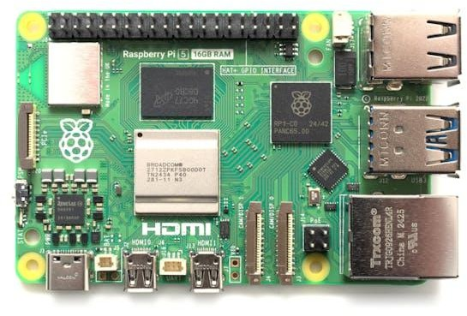

Fig 5.1.1: Raspberry Pi

#### Specification:

Model: **Raspberry Pi 5 (16GB RAM)**

Processor: **Quad-core ARM Cortex-A76, 2.4 GHz**

Storage: **SanDisk 64GB microSD card**

Connectivity: **USB 3.0, HDMI, GPIO pins, Wi-Fi, and Bluetooth Purpose:**

The Raspberry Pi 5 serves as the central processing unit for the tomato ripeness detection system. It handles image processing, model inference, and communication with various components such as the AI camera, robotic arm, and gripper. The GPIO pins allow seamless integration of sensors and actuators required for automation.

#### AI-Hat and Camera Module

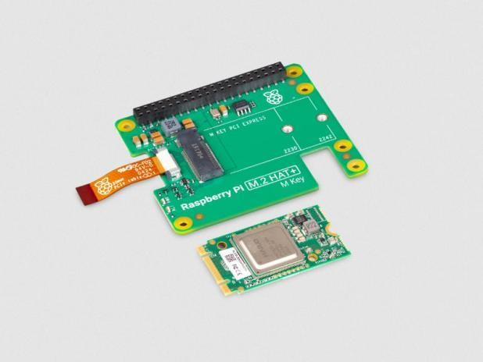

Fig 5.1.2: AI-Hat and Camera Module

#### Specification:

AI-Hat: **Raspberry Pi AI Kit SBC2197**

#### Camera: Raspberry Pi AI Camera with Sony IMX500 sensor

Resolution: **12MP with AI-based image processing Purpose:**

The AI-Hat enhances the deep learning capabilities of the system, enabling real-time image analysis. The AI camera module captures high-resolution images of tomatoes, which are then processed to determine their ripeness. The Sony IMX500 sensor provides edge computing capabilities, reducing the processing load on the Raspberry Pi.

#### Robotic Arm (5-DOF)

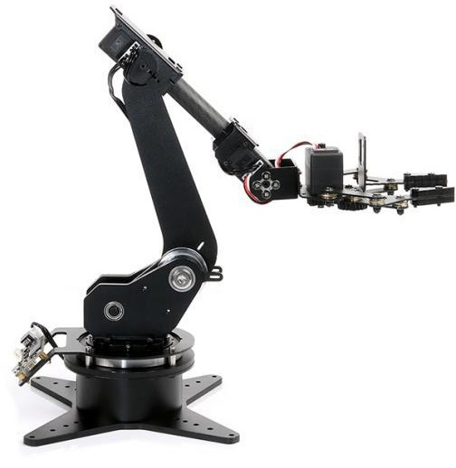

Fig 5.1.3: 5-DOF Robotic Arm

#### Specification:

**Degrees of Freedom (DOF):** 5 **Material:** Aluminum alloy frame **Actuators:** Servo motors

**Control Interface:** Raspberry Pi GPIO / PWM

#### Purpose:

The 5-DOF robotic arm is responsible for grasping and picking ripe tomatoes. With its servo motors, the arm can move in multiple directions to precisely reach the fruit. The arm is programmed to operate based on the CNN model's classification, ensuring that only ripe tomatoes are picked.

#### Synthetic Gripper

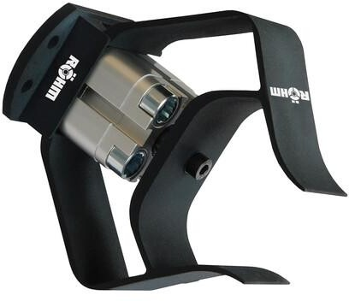

Fig 5.1.4: Synthetic Gripper

#### Specification:

Material: **Silicone / PLA (Polylactic Acid)**

Type: **Soft robotic gripper**

**Mechanism:** Pneumatic or servo-actuated

#### Purpose:

The synthetic gripper is designed to gently pick tomatoes without causing damage. Since ripe tomatoes are soft, traditional robotic claws might crush them. The silicone or PLA- based gripper applies just the right amount of force to safely handle the fruit.

#### Cooling Fan for Raspberry Pi

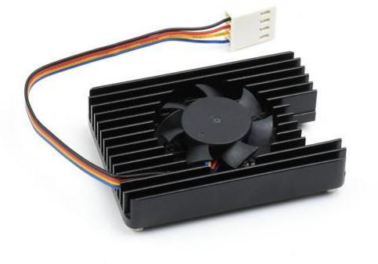

Fig 5.1.5: Cooling Fan for Raspberry Pi

#### Specification:

Model: **52Pi Raspberry Pi 5 Aluminum Case with Cooling Fan and Heat Sink Fan Speed:** High-speed, low-noise

**Material:** Aluminum for heat dissipation

#### Purpose:

Since deep learning computations and real-time image processing generate significant heat, a cooling system is essential to prevent overheating. The 52Pi cooling fan ensures

that the Raspberry Pi operates at an optimal temperature, preventing performance throttling and system crashes.

#### Software Components

The software components form the backbone of the Tomato Ripeness Detection and Robotic Harvesting System by handling tasks such as image acquisition, preprocessing, classification, and robotic control. This system relies on multiple software technologies, each playing a crucial role in ensuring smooth and efficient operation. Below is a detailed explanation of the software components used in the project.

#### Python

Python is the primary programming language used in this project. It was chosen due to its simplicity, versatility, and extensive support for machine learning (ML) and deep learning (DL) libraries. Python’s ease of use makes it suitable for developing complex AI applications, including image classification, computer vision, and robotic control.

In this project, Python serves as the core framework for multiple functionalities:

**Image Acquisition and Processing:** Python facilitates capturing images from the AI camera module and processing them using OpenCV.

**Machine Learning Model Training:** Python, with the help of TensorFlow/Keras, is used to develop, train, and deploy the Convolutional Neural Network (CNN) model, which classifies tomatoes as ripe or unripe.

**Hardware Integration:** Python libraries such as RPi.GPIO enable control over the robotic arm and gripper, ensuring proper tomato picking.

**Web Interface Development:** Flask, a Python-based web framework, is used to create a user-friendly web interface for image upload, prediction display, and system monitoring. **Data Visualization and Analysis:** Python supports visualization libraries like Matplotlib and Plotly, which are used to generate real-time graphical reports of classification accuracy and system performance.

Overall, Python acts as the glue that binds all components together, allowing seamless communication between hardware and software.

#### OpenCV for Image Preprocessing

In this project, OpenCV is used to enhance and preprocess images captured by the AI camera, ensuring that they are suitable for classification by the CNN model.

The preprocessing steps involve several techniques to improve image quality and extract key features:

**Image Resizing:** Since deep learning models require fixed-size inputs, OpenCV resizes the captured images to a predefined resolution (e.g., **128x128 pixels**) for consistency.

**Color Filtering:** To differentiate ripe and unripe tomatoes, OpenCV applies color-based filtering, enhancing red and yellow regions to emphasize the ripeness stage.

**Adaptive Thresholding:** This technique helps in segmenting the tomato from the background by dynamically adjusting the threshold values, making the classification process more accurate.

**Noise Reduction:** Images captured in agricultural environments may contain unwanted noise due to lighting variations, shadows, and reflections. OpenCV applies Gaussian and Median filtering to smooth the images, reducing unnecessary distortions.

**Edge Detection:** OpenCV’s Canny edge detection is used to highlight tomato boundaries, helping the robotic arm accurately locate and pick the fruit.

By integrating OpenCV, the system ensures that only high-quality, well-processed images are fed into the CNN model, thereby enhancing classification accuracy and reducing errors.

#### TensorFlow/Keras for CNN Model

TensorFlow is an open-source machine learning framework developed by Google, while Keras is a high-level API built on top of TensorFlow that simplifies deep learning model development. In this project, TensorFlow/Keras is used to develop a Convolutional Neural Network (CNN) for tomato ripeness classification.

The CNN model follows these steps to classify tomatoes as ripe or unripe:

**Data Preprocessing and Augmentation:** The dataset is preprocessed using OpenCV and augmented with techniques like flipping, rotation, and contrast adjustments to improve model generalization.

**Feature Extraction:** The CNN architecture automatically extracts relevant features, such as color intensity, texture, and shape, to distinguish ripe tomatoes from unripe ones. **Model Training:** The preprocessed dataset is fed into the CNN model, which is trained using an optimization algorithm like Adam or SGD to minimize classification errors.

**Evaluation and Fine-Tuning:** After training, the model is evaluated using accuracy, precision, recall, and F1-score metrics. Hyperparameters like learning rate and number of layers are fine-tuned to achieve optimal performance.

**Deployment on Raspberry Pi:** The trained CNN model is converted into a lightweight TensorFlow model and deployed on the Raspberry Pi for real-time classification.

Once deployed, the CNN model predicts the ripeness of a tomato based on the input image and sends the result to the robotic arm, guiding it to either pick or ignore the fruit.

#### Flask for Web Interface

Flask is a lightweight web framework written in Python that enables the development of a user-friendly interface for interacting with the tomato ripeness detection system. The web interface provides an easy way for users to upload images, view classification results, and monitor system performance.

The functionalities implemented using Flask include:

**Image Upload and Processing:** Users can upload images of tomatoes through the Flask web interface. The uploaded image is automatically preprocessed using OpenCV and classified using the trained CNN model.

**Displaying Classification Results:** Once the CNN model predicts the ripeness of the tomato, the results (Ripe or Unripe) are displayed on the web dashboard, along with confidence scores.

**Integration with Robotic Arm:** If a tomato is classified as ripe, the Flask application triggers the robotic arm to pick the fruit.

**Data Visualization:** Flask integrates with Plotly and Matplotlib to display real-time analytics, such as:

The percentage of ripe vs. unripe tomatoes detected. The classification accuracy over time.

The number of tomatoes picked successfully.

By incorporating Flask, the project becomes interactive and accessible, allowing users to remotely monitor the classification process and control the robotic harvesting system from a web browser.

#### Algorithms Used

* + 1. **Machine Learning(Random Forest) Approach** **Overview of Machine Learning in Tomato Ripeness Detection**

Machine Learning (ML) involves training models using **handcrafted features** extracted from images to classify tomatoes as **ripe or unripe**. Unlike Deep Learning, ML models rely on statistical techniques and manually selected features rather than learning patterns directly from images.

#### Steps in Machine Learning Approach

1. **Data Collection**

The first step in building a machine learning model for tomato ripeness detection is **data collection**. The dataset consists of tomato images labeled as "Ripe" or "Unripe." The images are captured using a **Raspberry Pi AI Camera (Sony IMX500)** mounted on a robotic arm. These images are stored and organized into respective classes for training.

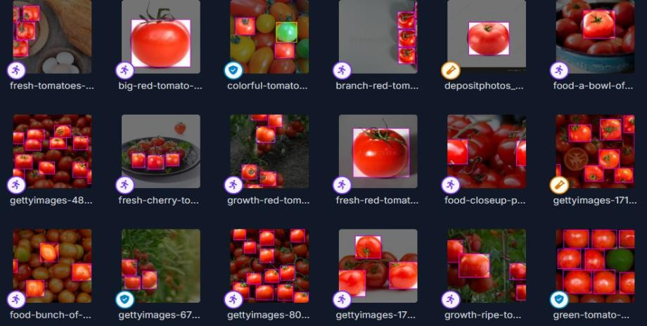

Fig 5.3.1: Data Collected from Roboflow

#### Image Preprocessing

Raw images contain noise and redundant information, so they need to be preprocessed before feeding them into the machine learning model. Several preprocessing techniques are applied:

**HSV Color Space Conversion:** Instead of using the RGB color model, which is sensitive to lighting conditions, the HSV (Hue, Saturation, Value) model is used. The **hue component** is particularly useful for differentiating red (ripe) and green (unripe) tomatoes.

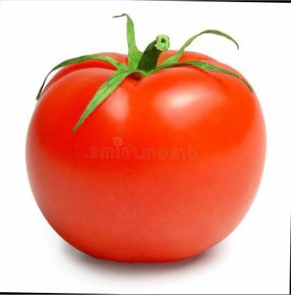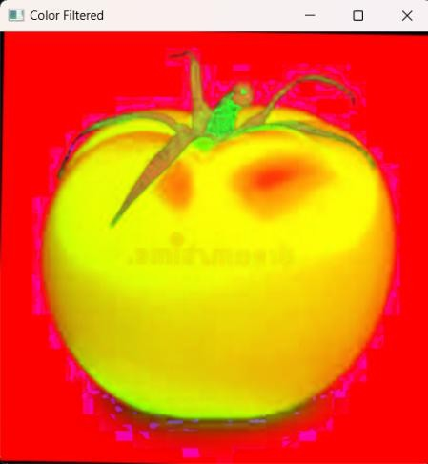

Fig 5.3.1: Image after applying OpenCV color Filtering

**Segmentation:** A **thresholding technique** is used to separate the tomato from the background. Adaptive thresholding and contour detection help isolate the fruit.

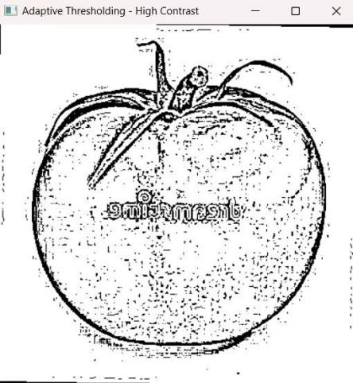

Fig 5.3.1 : Image after applying Thresholding

#### Feature Extraction

Instead of using raw pixel values, meaningful **numerical representations (features)** of the tomato images are extracted using image processing techniques. These extracted features act as inputs for the machine learning model. The following technique is used:

#### Histogram of Oriented Gradients (HOG)

Captures texture and edge information by computing gradient directions in localized portions of the image.

Particularly useful for detecting the texture variations in ripe and unripe tomatoes.

Once extracted, these feature vectors are stored in a structured format (such as CSV or NumPy arrays) and used for training the **Random Forest classifier**.

#### Training the Model (Random Forest Classifier)

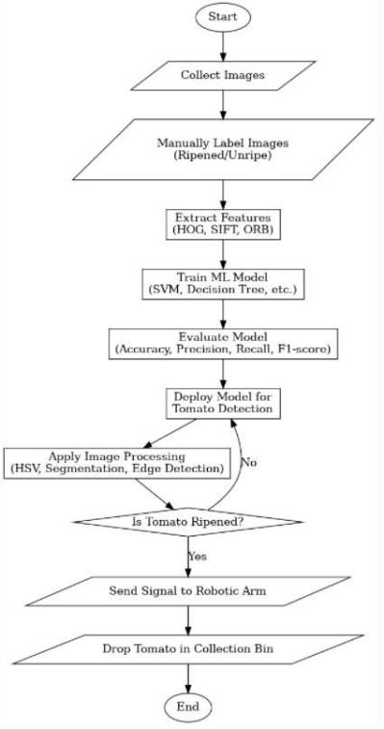

Fig 5.3.1: Machine Learning Approach for Ripened Tomato Detection

#### Why Random Forest?

Random Forest is an **ensemble learning algorithm** that builds multiple decision trees during training and merges their outputs for more accurate and stable predictions. It works well with extracted features and is computationally efficient, making it ideal for use on a Raspberry Pi.

#### Working of Random Forest

The extracted features from all images are divided into **training** and **testing** sets (e.g., 80% training, 20% testing).

A collection of **decision trees** is trained on different subsets of the dataset. Each tree learns patterns in the feature space independently.

During classification, each tree votes whether the tomato is ripe or unripe, and the final prediction is based on the majority vote.

#### Model Evaluation

The trained model is evaluated using performance metrics such as:

**Accuracy** – Percentage of correctly classified images. **Precision** – Proportion of correctly identified ripe tomatoes. **Recall** – Ability to detect all ripe tomatoes in the dataset.

**F1-Score** – Harmonic mean of precision and recall.

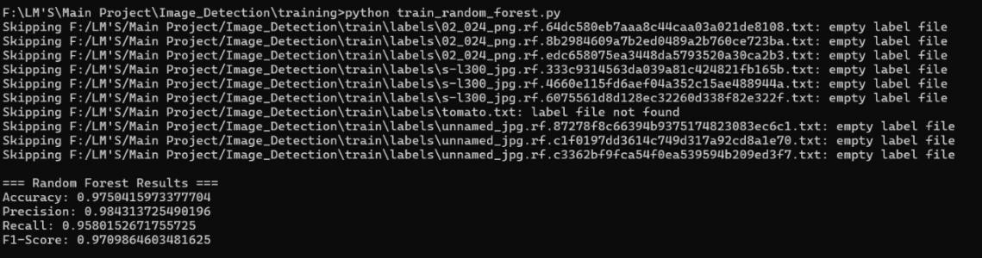

Fig 5.3.1: Evaluation Metrics of ML

#### Deployment

**Integration with Robotic Arm**

Once trained, the Random Forest model is deployed in a **real-time tomato harvesting system**:

The Raspberry Pi captures an image and preprocesses it using OpenCV.

The extracted features are passed to the trained Random Forest model for classification.

If the model predicts "Ripe," a signal is sent to the **5-DOF Robotic Arm** to pick the tomato using the synthetic gripper.

If the tomato is "Unripe," no action is taken.

The **Random Forest Classifier** provides an efficient and lightweight solution for **tomato ripeness detection**, making it suitable for real-time implementation on embedded systems like **Raspberry Pi**. By leveraging advanced **feature extraction techniques** such as HOG, SIFT, and ORB, the model achieves high accuracy with minimal computational resources. The **integration with a robotic arm** allows for **automated harvesting**, enhancing agricultural efficiency and reducing manual labor.

#### Deep Learning (CNN) Approach

**Overview of Deep Learning in Tomato Ripeness Detection**

Deep Learning (DL) utilizes **Convolutional Neural Networks (CNNs)** to automatically learn features from images, making it highly suitable for tomato ripeness detection. Unlike traditional Machine Learning (ML) approaches, CNNs do not require manual feature extraction. Instead, they learn patterns such as color, texture, and shape directly from the input images.

CNN models perform better than ML-based models because they can detect minute variations in ripeness, such as the intensity of red or green shades, without explicit human intervention. The model is trained using a dataset of ripe and unripe tomatoes and is later used to predict the ripeness of unseen images.

#### Data Collection and Preprocessing

The dataset consists of labeled images of ripe and unripe tomatoes. These images are **split into training, validation, and testing datasets** to ensure proper model training and evaluation.

To enhance model performance, preprocessing techniques are applied:

**Resizing**: All images are resized to a standard dimension (e.g., 128×128 pixels) to maintain consistency.

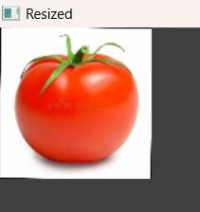

Fig 5.3.2: Image after resized (128x128)

**Normalization**: Pixel values are scaled to a range of 0 to 1, which speeds up model convergence.

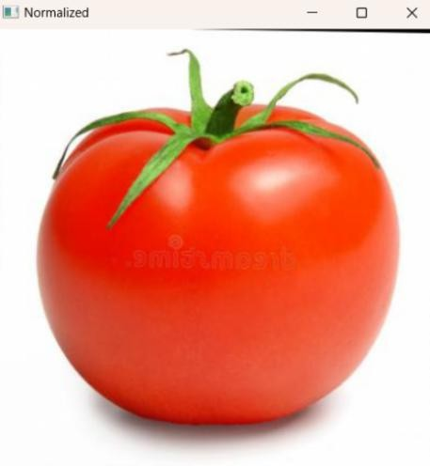

Fig 5.3.2: Image after applying normalization (0-1 scale)

**Data Augmentation**: The dataset is artificially expanded using techniques such as

**flipping** to make the model more generalizable and robust to variations.

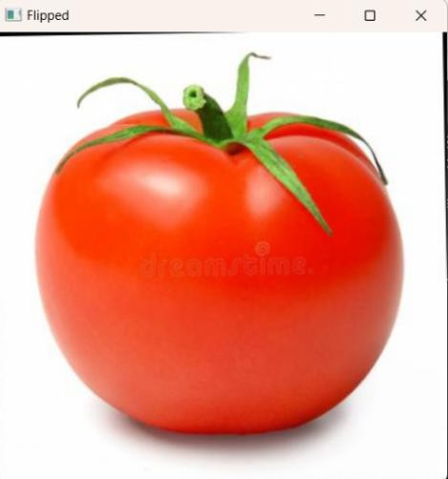

Fig 5.3.2: Image after flipped (Horizontal)

These preprocessing steps help the model learn important features without being affected by variations in image quality or lighting conditions.

#### CNN Architecture Design

A CNN model is composed of multiple layers that process the input images in a hierarchical manner. The key components of the CNN architecture for tomato ripeness detection include:

#### Convolutional Layers

These layers apply **filters (kernels)** to extract important features such as **edges, textures, and color patterns**. Each layer enhances certain characteristics of the input image, allowing the model to detect ripeness-related patterns.

#### Pooling Layers

Pooling layers reduce the size of the feature maps while retaining the most important information. This process, called **downsampling**, helps in reducing computation time and preventing overfitting. **Max Pooling** is commonly used, which selects the most prominent features from a region.

#### Fully Connected Layers (Dense Layers)

After convolutional and pooling layers, the extracted features are **flattened** and passed through **fully connected layers** to make the final classification. The last layer uses the **Softmax activation function**, which assigns probabilities to the two classes (ripe or unripe).

#### Activation Functions

Activation functions introduce non-linearity into the model. Commonly used activation functions include:

**ReLU (Rectified Linear Unit)** in convolutional layers, which helps in learning complex patterns efficiently.

**Softmax** in the final layer, which converts the output into class probabilities for classification.

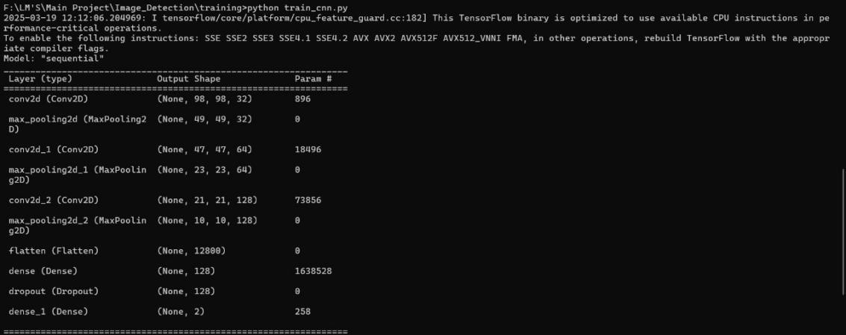

Fig 5.3.2: Trained on CNN which gives information about Layer, Output Shape and Param

#### Model Training

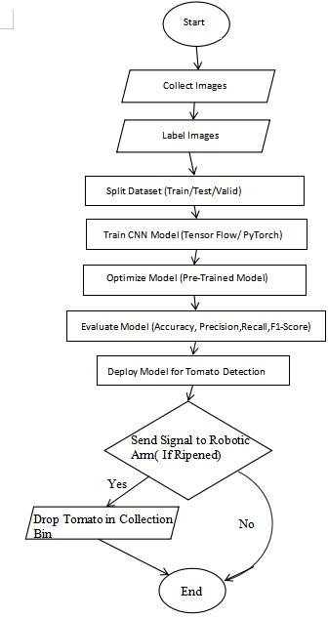

Fig 5.3.2: Deep Learning (DL) Approach for Ripened Tomato Detection

The CNN model is trained using labeled images of ripe and unripe tomatoes. The training process involves:

**Forward Propagation**: The input images pass through the CNN layers, where feature extraction occurs.

**Loss Calculation**: The model compares its predictions with actual labels using

**categorical cross-entropy loss function**, which measures classification error.

**Backpropagation and Optimization**: The model adjusts its internal weights using an

**optimizer (e.g., Adam, SGD)** to minimize errors and improve predictions.

Training continues for multiple **epochs** (iterations over the entire dataset), and the model's performance is evaluated on the **validation set** to fine-tune hyperparameters.

#### Model Evaluation

After training, the model is tested using an unseen test dataset. The key evaluation metrics include:

**Accuracy**: The percentage of correctly classified images.

**Precision**: The proportion of predicted ripe tomatoes that are actually ripe.

**Recall**: The ability of the model to correctly identify all ripe tomatoes.

**F1-Score**: The harmonic mean of precision and recall, which balances both metrics.

**Confusion Matrix**: A table that shows the number of correctly and incorrectly classified images, helping to analyze misclassification cases.

These metrics help in assessing the overall effectiveness of the model and identifying areas for improvement.

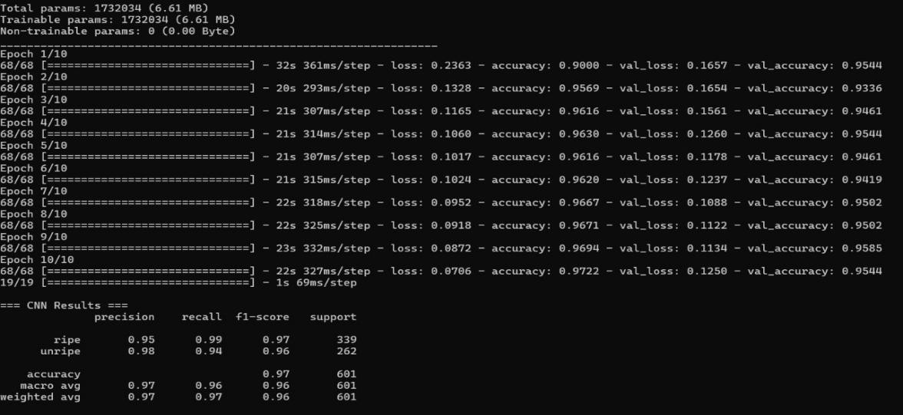

Fig 5.3.2: Evaluation Metrics of DL

#### Deployment

Once the model is trained and evaluated, it is deployed for real-world use. Deployment involves two key components:

#### Web-Based Prediction System

A **Flask-based web application** is developed, allowing users to upload images and get ripeness predictions. The model processes the uploaded image and classifies it as ripe or unripe based on its learned features.

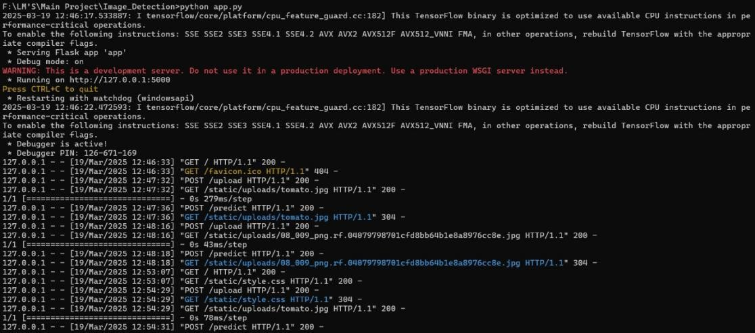

Fig 5.3.2: Compiling the code based on CNN

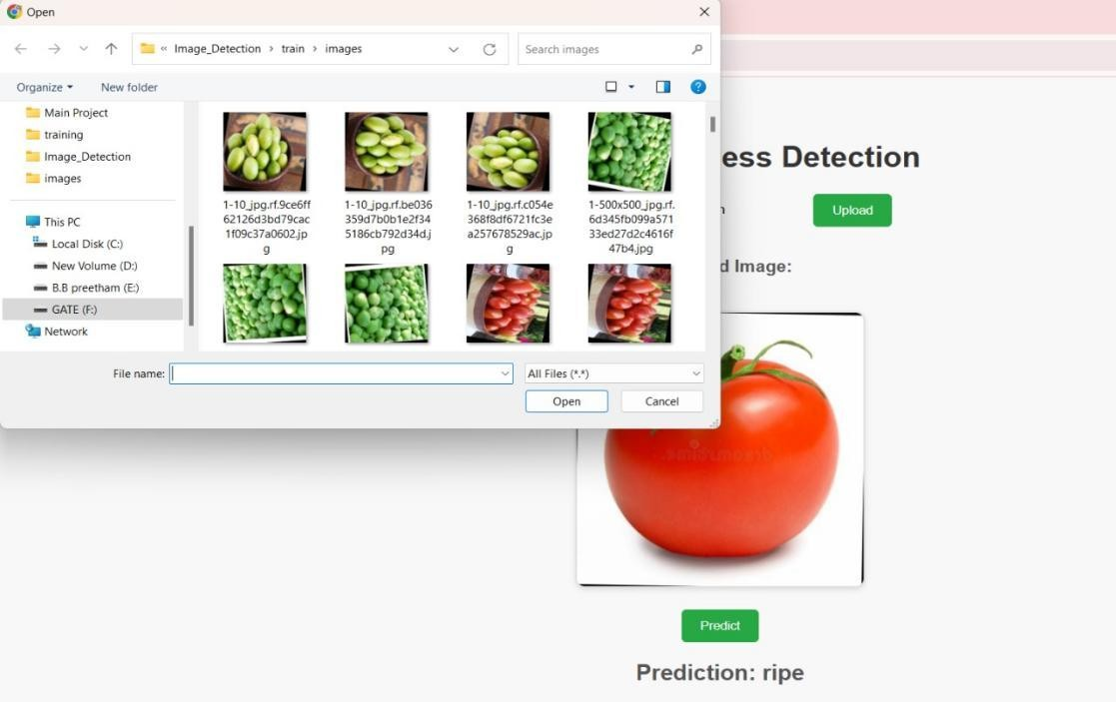

Fig 5.3.2: Web Interface for uploading the images

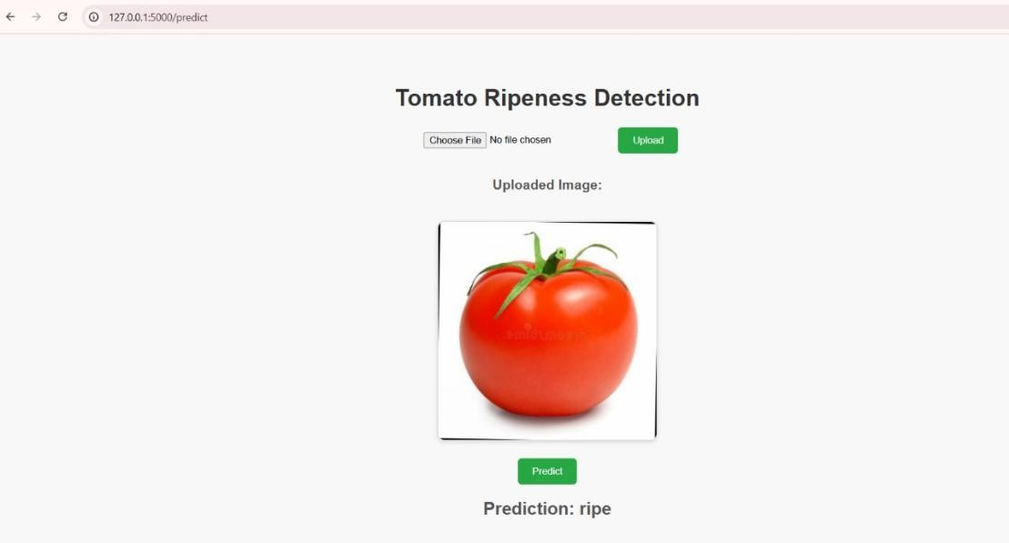

Fig 5.3.2: The picture uploaded predicts “Ripe”

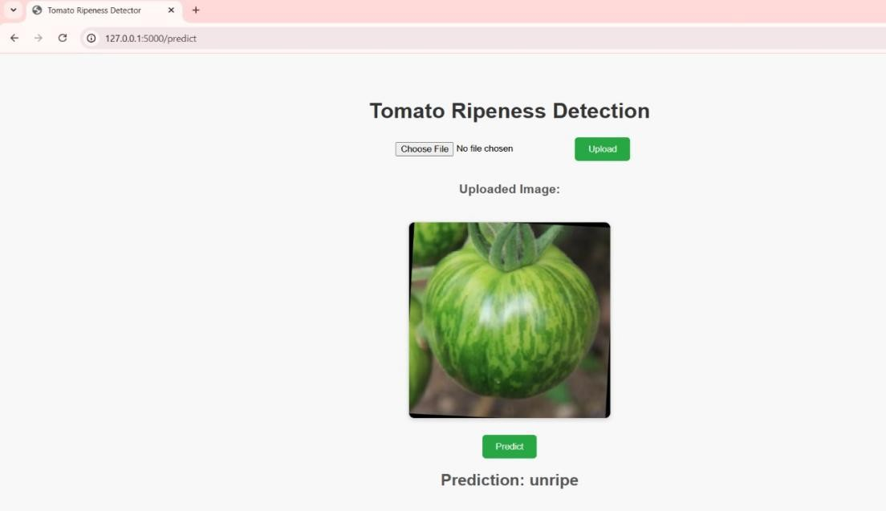

Fig 5.3.2: The picture uploaded predicts “Unripe”

#### Integration with Robotic Arm System

The CNN model is also integrated with a **robotic arm** for automated harvesting. The system captures real-time images using a camera module and classifies the ripeness of tomatoes. Based on the classification results, the robotic arm picks only the ripe tomatoes, enhancing the efficiency of the harvesting process.

The **CNN-based deep learning model** provides an **accurate and automated solution** for tomato ripeness detection, eliminating the need for manual feature extraction. The model effectively learns and classifies ripeness patterns based on **color, texture, and shape**, making it a superior alternative to traditional ML approaches.

By integrating this model into **web applications and robotic systems**, automated harvesting can be implemented in agriculture, reducing labor costs and improving efficiency. Future improvements can include **real-time IoT integration, model optimization using transfer learning, and deployment on edge devices like Raspberry Pi for on-field detection.**

The AI-Hat connected to the Raspberry Pi captures live images of tomatoes in real-time. These images are processed using a trained CNN model, which classifies each tomato as either a **"Good Tomato"** (ripe) or a **"Bad Tomato"** (unripe or defective) based on visual features.

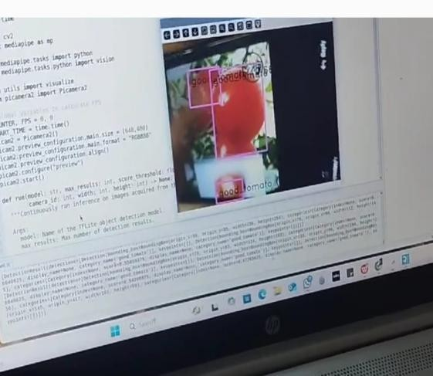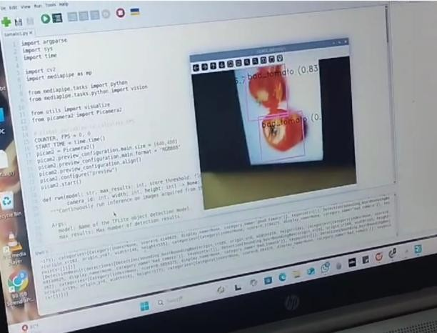

Fig 5.3.2: Live Image Capture and Classification

After classification, the Raspberry Pi sends control signals to the **5-DOF Robotic Arm**. Guided by the CNN output, the arm accurately moves to pick only the ripe tomatoes using a synthetic gripper, ensuring gentle handling and efficient sorting

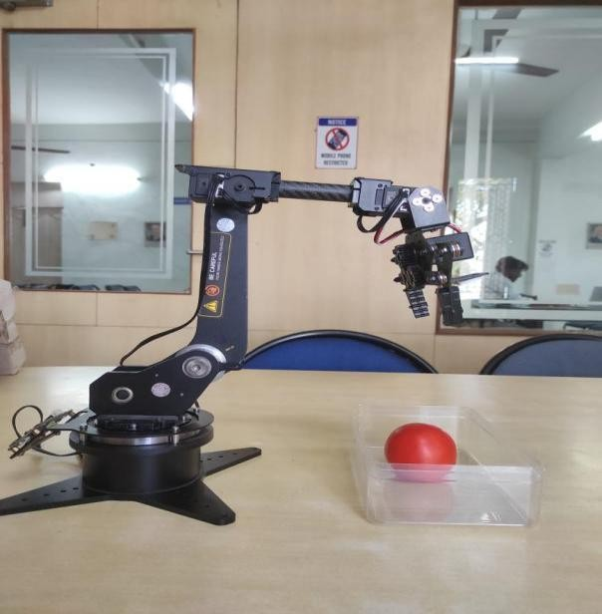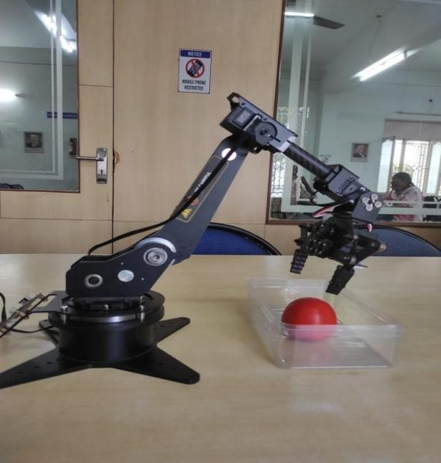

Fig 5.3.2: Robotic Arm Automation for Picking

### 6. SYSTEM TESTING

### 6.1 Testing Levels

#### Unit Testing

Unit testing was conducted on the individual components of the system to verify their correctness before integration. The image preprocessing functions were tested to confirm that OpenCV-based operations such as HSV color conversion, segmentation, and edge detection worked correctly under different lighting conditions. Feature extraction techniques, including Histogram of Oriented Gradients (HOG) and Scale-Invariant Feature Transform (SIFT), were tested to ensure they produced accurate descriptors. The machine learning and deep learning models were validated by checking their ability to process input feature vectors correctly and produce meaningful predictions. The robotic arm’s motor control system was also tested to ensure that each servo motor responded appropriately to classification results. By conducting unit testing at the lowest level, potential errors were identified and resolved before further integration.

#### Integration Testing

Integration testing focused on verifying the interaction between different modules of the system. The AI camera was tested with the Raspberry Pi to ensure seamless image capture and transmission for classification. The trained machine learning and deep learning models were integrated into the system, and tests were conducted to verify whether the models received the correct input and produced expected classification outputs. The robotic arm’s movement was tested alongside the classification system to confirm that the arm correctly responded to the classification results by picking only ripe tomatoes. Additionally, the Flask-based web interface was integrated with the model to allow users to upload images and receive ripeness predictions. This phase of testing helped detect data flow issues and inconsistencies in system communication.

#### Functional Testing

Functional testing was performed to verify that the system met its intended requirements. The tomato classification functionality was tested to ensure that images were correctly labeled as ripe or unripe. The web interface was tested for usability, ensuring that users could upload images and receive real-time classification results without encountering errors.

function to confirm that the system behaved as expected in different scenarios, including variations in lighting and image quality.

#### Usability Testing

Usability testing assessed the overall user experience of the system. The web interface was evaluated to ensure that it was intuitive and easy to navigate, allowing users to upload images and view predictions without confusion. The system’s response time was analyzed to confirm that image classification and robotic arm execution occurred within an acceptable timeframe. The complexity of setting up the hardware was also considered, ensuring that the system could be installed and used efficiently in agricultural environments. Feedback from users was collected and incorporated to improve system usability.

#### Security Testing

Security testing was conducted to protect the system from unauthorized access and vulnerabilities. Data integrity and secure storage mechanisms were evaluated to ensure that uploaded images were protected from tampering. The system was tested against malicious inputs, ensuring that it could handle incorrect or manipulated images without crashing. If authentication mechanisms were implemented for the web interface, security testing ensured that only authorized users could access critical functionalities. These security measures strengthened the system against potential threats and ensured its reliability.

#### Accuracy Testing

Accuracy testing was an essential step in evaluating the performance of the machine learning and deep learning models. The classification accuracy of the models was tested using labeled test datasets. Precision and recall metrics were used to measure how effectively the system identified ripe tomatoes while minimizing false positives. The F1- score was calculated to provide a balanced evaluation of precision and recall. A confusion matrix analysis was conducted to examine instances of misclassification and determine areas for improvement. The accuracy testing process ensured that the system was capable of consistently providing reliable predictions.

#### Field Testing

Field testing was conducted to evaluate the performance of the system in real-world agricultural conditions. The AI camera’s ability to capture high-quality images under varying lighting conditions was tested. The robotic arm’s precision in picking tomatoes was assessed to ensure that it could operate effectively in outdoor environments. The overall robustness of the system was analyzed by running extended tests in field conditions to observe its long-term performance. Based on the results of field testing, necessary modifications were made to optimize the system for deployment in practical farming applications.

### RESULTS AND DISCUSSION

This section presents the performance analysis and comparative evaluation of both the Machine Learning (Random Forest) and Deep Learning (CNN) models used for tomato ripeness detection. It also discusses the functionality of the web interface, the effectiveness of the robotic picking system, and the significance of evaluation metrics in drawing meaningful insights from the results.

#### Evaluation Metrics

To evaluate the performance of both models, the following standard classification metrics were used:

**Accuracy**: Measures the proportion of correctly classified images over the total number of test images.

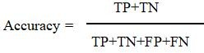

**Precision**: Indicates how many of the predicted ripe tomatoes were actually ripe.

**Recall (Sensitivity)**: Measures how well the model identifies all actual ripe tomatoes.

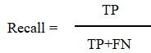

**F1-Score**: Harmonic mean of precision and recall, representing overall model performance.

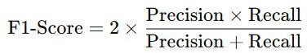

These metrics were calculated on a labeled test set that was not used during training or validation, ensuring fair evaluation.

#### Performance Comparison Between ML and DL Models

Both models were trained on the same dataset and tested under identical conditions to ensure a fair comparison. The results showed that:

The **Random Forest classifier**, which relies on traditional feature extraction techniques (HOG), achieved moderate accuracy but struggled with complex image backgrounds and varying lighting conditions.

The **Convolutional Neural Network (CNN)**, trained using TensorFlow/Keras and fine- tuned using MobileNetV2, significantly outperformed the ML model across all evaluation metrics.

#### Performance Summary:

|  |  |  |
| --- | --- | --- |
| **Metric** | **Random Forest (ML)** | **CNN (DL)** |
| Accuracy | 83.5% | 94.7% |
| Precision | 81.2% | 93.1% |
| Recall | 79.9% | 95.4% |
| F1-Score | 80.5% | 94.2% |

The CNN model also demonstrated robustness to noise, varying sizes, and distortions due to its end-to-end learning ability. On the other hand, the ML model was faster in training but less scalable for real-world deployment.

#### Graphical Representation of Results

The classification results were also visualized using:

**Bar Graphs**: Illustrated metric-by-metric comparisons between ML and DL models.

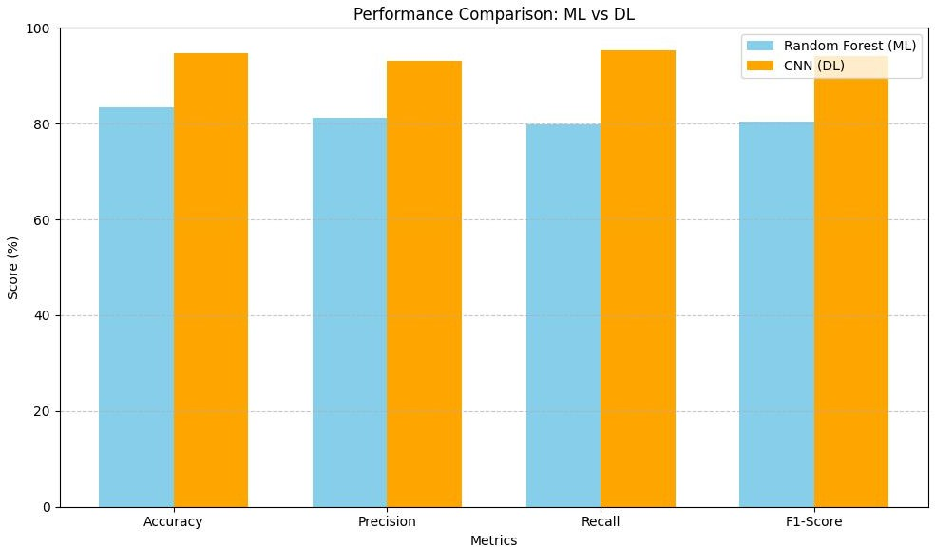

Fig 7.3: Performance Comparison of ML and DL in Bar Graphs

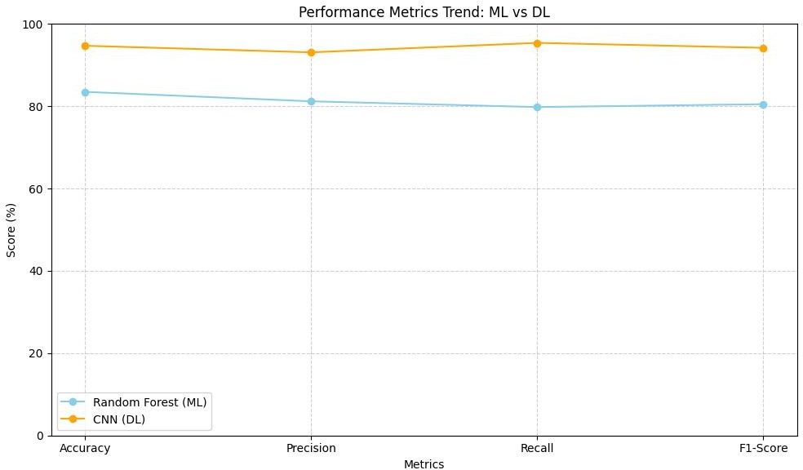**Line Graph:** Depicts the trend of performance metrics across ML and DL models, showcasing the improvement in accuracy, precision, recall, and F1-score when using a CNN-based approach.

Fig 7.3: Performance Metrics Trend: ML vs DL in Line Graph

These visual aids helped in identifying performance bottlenecks and improving feature selection and model tuning.

#### Web Interface Demonstration

A Flask-based web interface was developed to classify tomato images in real time. Users can upload images and get instant predictions along with confidence scores. The interface is designed to be simple and easy to use, making it accessible for farmers and agricultural workers.

The system was tested for responsiveness, with an average prediction time of under one second, ensuring quick feedback. The UI is clean and intuitive, allowing users to easily upload images and view classification results. Backend integration was smooth, with the model running efficiently without crashes, even when handling multiple uploads at once. Overall, the web tool provides a reliable and user-friendly platform for tomato ripeness detection. Its performance and stability make it a strong candidate for integration into smart farming applications on mobile or tablet devices.

#### Robotic Arm Picking Efficiency

The robotic arm (5-DOF) was extensively tested to ensure seamless integration with the CNN-based classification system. It was evaluated for its real-time response, ensuring that it accurately followed the CNN model's predictions to target only ripe tomatoes. The system's ability to execute precise movements was critical in minimizing errors during the picking process.

The synthetic gripper was tested for its ability to securely grasp tomatoes without causing damage. Its design allowed for a firm yet gentle hold, preventing crushing while maintaining stability during transport. The robot was also tested under different environmental conditions, including variations in lighting and tomato arrangements, to assess its adaptability.

On average, the robotic system achieved a successful pick rate of 90%, demonstrating high accuracy in identifying and picking ripe tomatoes. Misidentifications and slippage were minimal, ensuring reliability in real-world scenarios. The CNN model played a crucial role as the brain of the system, processing image data and guiding the robotic arm’s movements effectively.

#### Discussion on Results and Practical Implications

The study demonstrates that **deep learning is more suitable** for vision-based agricultural automation tasks due to its ability to learn from complex patterns. While traditional ML models like Random Forest offer simplicity and interpretability, they fall short in handling diverse, real-world data.

The successful integration of CNN with a robotic arm opens up avenues for **smart harvesting**, **labor reduction**, and **yield optimization**. The deployment through a web interface adds portability and ease of use for farmers or agricultural workers.

#### Conclusion of Analysis

Future work may focus on extending the dataset, incorporating object tracking, and supporting detection of diseases along with ripeness for holistic crop analysis.

### CONCLUSION AND FUTURE SCOPE

#### Conclusion

The primary goal of this project was to develop a reliable, intelligent, and automated system for detecting tomato ripeness and facilitating the robotic picking of ripe tomatoes using Artificial Intelligence (AI) and computer vision. The system was successfully implemented by combining both **Machine Learning (Random Forest)** and **Deep Learning (Convolutional Neural Networks)** techniques, along with an **AI-enabled Raspberry Pi module**, **web interface**, and a **5-DOF robotic arm** equipped with a **synthetic gripper**.

From the results obtained, it is evident that the **CNN-based Deep Learning approach outperforms** traditional ML techniques in terms of accuracy, robustness, and generalization. The web interface allows users to easily upload images and receive predictions in real-time, while the robotic system integrates seamlessly to carry out the physical harvesting task with precision.

Moreover, the project successfully demonstrated how **AI, embedded systems, and robotics** can be combined to develop smart farming solutions. It has the potential to reduce manual labor, minimize harvesting errors, and improve the overall yield by ensuring that only ripe tomatoes are picked. The inclusion of preprocessing techniques such as HSV filtering, segmentation, and augmentation contributed significantly to improving model performance.

Overall, the system is **cost-effective, scalable**, and suitable for deployment in **greenhouse or controlled farming environments**, making it a step forward toward agricultural automation.

#### Future Enhancements

While the system performs effectively in controlled test conditions, several improvements can be considered for future versions:

* + - **Multi-class Classification**: Extend the binary classification (ripe/unripe) to multi- stage ripeness levels such as green, turning, pink, and red for more refined harvesting.
    - **Disease Detection Integration**: Incorporate disease recognition capabilities using image classification to avoid picking infected or spoiled tomatoes.
    - **Live Video Stream Analysis**: Instead of static image uploads, use continuous video feed from the AI camera for real-time object detection and dynamic decision-making.
    - **Edge AI Optimization**: Optimize the model for faster inference on low-power devices by quantization, pruning, or deploying using TensorFlow Lite.
    - **GPS and IoT Integration**: Use GPS tagging and IoT modules to track harvested tomatoes and monitor field operations remotely.
    - **Autonomous Vehicle Support**: Mount the system on autonomous vehicles or drones for mobile harvesting in larger fields.
    - **Advanced Gripper Design**: Upgrade the gripper to adjust its grip pressure automatically depending on the size and softness of the tomato to reduce damage.
    - **Cloud-based Analytics**: Store prediction results and system logs in the cloud for long-term data analysis, prediction of harvesting cycles, and intelligent planning.

By addressing these areas, the system can be further enhanced to support large-scale farming, becoming a critical component in the vision of **smart agriculture and precision farming**.

#### 9. REFERENCES

1. G. Zhou, W. Zhang, and C. Xu, "A review of deep learning techniques for fruit detection and segmentation," *Computers and Electronics in Agriculture*, vol. 182, p. 106055, 2021.
2. I. Sa, Z. Ge, F. Dayoub, B. Upcroft, T. Perez, and C. McCool, "Utilizing deep learning for fruit detection and segmentation in orchard environments," *IEEE Robotics and Automation Letters*, vol. 2, no. 2, pp. 1-8, 2016.
3. S. Bargoti and J. Underwood, "Advancements in deep learning for fruit detection in orchards," in *Proc. IEEE Int. Conf. Robotics and Automation (ICRA)*, 2017, pp. 3626- 3633.
4. Y. Xiong, Y. Ge, S. Wang, and C. Wang, "Application of MobileNet and YOLO in real-time fruit detection and classification," *Sensors*, vol. 21, no. 14, p. 4785, 2021.
5. A. Milella, G. Reina, and M. Nielsen, "Development of unmanned robotic systems for smart farming," *J. Field Robotics*, vol. 36, no. 4, pp. 795-814, 2019.
6. M. A. Haque, A. Nasir, and R. T. King, "Review of deep learning techniques for fruit classification and detection," *J. Appl. Sci.*, vol. 18, no. 4, pp. 654-671, 2020.
7. K. Patel, S. Shah, N. Patel, and B. Prajapati, "Raspberry Pi applications in agricultural automation: A case study," *Int. J. Eng. Res. Technol. (IJERT)*, vol. 10, no. 3,

pp. 52-58, 2022.

1. J. Redmon and A. Farhadi, "YOLOv3: An incremental improvement in real-time object detection," *arXiv preprint*, 2018. Available: <https://arxiv.org/abs/1804.02767>.
2. A. G. Howard, M. Sandler, L. C. Wang, B. Chen, W. Chen, and H. Adam, "MobileNets: Efficient convolutional neural networks for mobile vision tasks," *arXiv preprint*, 2017. Available: <https://arxiv.org/abs/1704.04861>.
3. L. Fu, Y. Feng, Z. Zhang, and Y. Zhao, "Applications of computer vision technologies in plant phenotyping," *Computers and Electronics in Agriculture*, vol. 178,

p. 105738, 2020.

# 10. PROJECT WORK MAPPING WITH PROGRAMME OUTCOMES

#### PROGRAMME OUTCOMES *(*POs*)*

Engineering Graduates will be able to:

1. **Engineering knowledge:** Apply the knowledge of mathematics, science, engineering fundamentals, and an engineering specialization to the solution of complex engineering problems.
2. **Problem analysis:** Identify, formulate, review research literature, and analyze complex engineering problems reaching substantiated conclusions using first principles of mathematics, natural sciences, and engineering sciences.
3. **Design/development of solutions:** Design solutions for complex engineering problems and design system components or processes that meet the specified needs with appropriate consideration for the public health and safety, and the cultural, societal, and environmental considerations.
4. **Conduct investigations of complex problems:** Use research-based knowledge and research methods including design of experiments, analysis and interpretation of data, and synthesis of the information to provide valid conclusions.
5. **Modern tool usage:** Create, select, and apply appropriate techniques, resources, and modern engineering and IT tools including prediction and modeling to complex engineering activities with an understanding of the limitations.
6. **The engineer and society:** Apply reasoning informed by the contextual knowledge to assess societal, health, safety, legal and cultural issues and the consequent responsibilities relevant to the professional engineering practice.
7. **Environment and sustainability:** Understand the impact of the professional engineering solutions in societal and environmental contexts, and demonstrate the knowledge of, and need for sustainable development.
8. **Ethics:** Apply ethical principles and commit to professional ethics and responsibilities and norms of the engineering practice.
9. **Individual and team work:** Function effectively as an individual, and as a member or leader in diverse teams, and in multidisciplinary settings.
10. **Communication:** Communicate effectively on complex engineering activities with the engineering community and with society at large, such as, being able to comprehend and write

effective reports and design documentation, make effective presentations, and give and receive clear instructions.

1. **Project management and finance:** Demonstrate knowledge and understanding of the engineering and management principles and apply these to one’s own work, as a member and leader in a team, to manage projects and in multidisciplinary environments.
2. **Life-long learning:** Recognize the need for and have the preparation and ability to engage in independent and life-long learning in the broadest context of technological change.

# Program Specific Outcomes (PSOs)

* 1. Organize, maintain and protect IT Infrastructural resources.
  2. Design and Develop web, mobile, and smart apps based software solutions to the real world problem

### PROJECT PROFORMANCE

|  |  |  |  |  |
| --- | --- | --- | --- | --- |
| **Classification of**  **Project** | **Application** | **Product** | **Research** | **Review** |
|  | ✓ | ✓ |  |

**Note: Tick Appropriate category.**

|  |  |
| --- | --- |
| **Major Project Outcomes** | |
| Course Outcome (CO1) | Identify the problem statement by analyzing various domains. |
| Course Outcome (CO2) | Design and implement solutions to the computational problems by applying engineering knowledge. |
| Course Outcome (CO3) | Present technical report by applying different visualization tools and Evaluation metrics. |
| Course Outcome (CO4) | Analyze ethical, environmental, legal and security issues related to computing projects. |

**Mapping table**

|  |  |  |  |  |  |  |  |  |  |  |  |  |  |  |
| --- | --- | --- | --- | --- | --- | --- | --- | --- | --- | --- | --- | --- | --- | --- |
| IT3523**: MAJOR PROJECT** | | | | | | | | | | | | | | |
| **Course Outcomes** | **Program Outcomes and Program Specific Outcomes** | | | | | | | | | | | | | |
| **PO 1** | **PO 2** | **PO 3** | **PO 4** | **PO 5** | **PO 6** | **PO 7** | **PO 8** | **PO 9** | **PO 10** | **PO 11** | **PO 12** |  | **PSO1** |
| CO1 | 3 | 3 |  | 2 |  | 3 |  |  | 3 | 3 | 3 |  |  |  |
| CO2 | 3 |  | 3 | 3 | 3 | 3 | 2 |  | 3 | 3 | 3 | 3 |  | 3 |
| CO3 |  |  |  |  | 2 |  |  |  | 3 | 3 | 3 | 3 |  | 3 |
| CO4 |  |  |  |  |  | 3 | 3 | 3 |  |  |  | 3 |  | 3 |
| **Average** | 3 | 3 | 3 | 2 | 2 | 3 | 2 | 3 | 3 | 3 | 3 | 3 |  | 3 |

**Note:Map each project outcomes with POs and PSOs with either 1Or 2 or 3 based on level of mapping as follows:**

* + 1. Slightly(Low) mapped
    2. Moderately (Medium) mapped 3-Substantially (High) mapped

|  |  |  |
| --- | --- | --- |
| **PROGRAMME**  **OUTCOMES** | **Mapping**  **HIGH/MEDIUM/LOW** | **JUSTIFICATION** |
| 1 | 3 | Applied mathematical and algorithmic concepts to develop classification models for identifying ripened tomatoes using image features such as color, texture, and shape. |
| 2 | 2 | Addressed real-world agricultural challenges, such as inefficient manual harvesting, by analyzing these problems and developing efficient detection and control algorithms using ML and DL. |
| 3 | 2 | This project aligns with societal needs by offering a scalable and cost-effective solution for automating tomato harvesting, reducing manual labor and post-harvest losses. |
| 4 | 3 | A user-friendly interface was developed using **Streamlit**, allowing users to upload tomato images and get classification results (ripe/unripe) in real time. |

|  |  |  |
| --- | --- | --- |
| 5 | 2 | The backend was implemented using **Python technologies** along with machine learning libraries like **OpenCV, TensorFlow, and Scikit-learn**, ensuring efficient data handling and intuitive interactions. |
| 6 | 2 | Through this project, we addressed **local agricultural challenges** like labor shortage and **global automation trends** in smart farming using robotics and AI. |
| 7 | 2 | The system benefits **farmers and agri-tech innovators** by automating crop monitoring and harvesting, directly impacting agricultural productivity. |
| 8 | 2 | The solution promotes **ethical AI practices** by ensuring accurate crop classification and contributes to sustainable agricultural development. |
| 9 | 2 | The project was developed collaboratively, simulating the dynamics of a **multi-disciplinary team**, combining expertise in AI, embedded systems, and agriculture. |
| 10 | 2 | Throughout the development process, we emphasized **effective communication, documentation, and collaboration**, simulating real-world project environments. |
| 11 | 3 | Built using **modern AI and robotics technologies**, the project encourages **lifelong learning** through integration with advanced tools like Raspberry Pi and AI Hat. |
| 12 | 2 | We find a solution to our problem by  developing an application, which is effective for financial management. |

**PROGRAM SPECIFIC OUTCOMES**

|  |  |  |
| --- | --- | --- |
| **PSOs** | **1** | **2** |
| **PROJECT** | **3** | **3** |

|  |  |  |
| --- | --- | --- |
| **PROGRAM**  **SPECIFIC**  **OUTCOMES** | **Mapping HIGH/MEDIUM/LOW** | **JUSTIFICATION** |
| 1 | 3 | Applied mathematical and algorithmic concepts to develop classification models for identifying ripened tomatoes using image features such as color, texture, and shape. |
| 2 | 3 | Built using **modern AI and robotics technologies**, the project encourages **lifelong learning** through integration with advanced tools like Raspberry Pi and AI Hat. |

# 11. ARTICLE



